Lab Objective

Learn how to approve the updates that need to be pushed from WSUS server.

**Lab Procedures**

**1.** On Server01, go to the Update Services console.

**2.** In the left pane, expand Server01 and click Updates.

**3.** Click Updates installed/not applicable under Critical Updates.

**4.** On the top of the screen, on the Approval drop-down menu, make sure Unapproved is selected. On the top of the screen, on the Status drop-down menu, make sure Any is selected as shown in Figure 2-8.

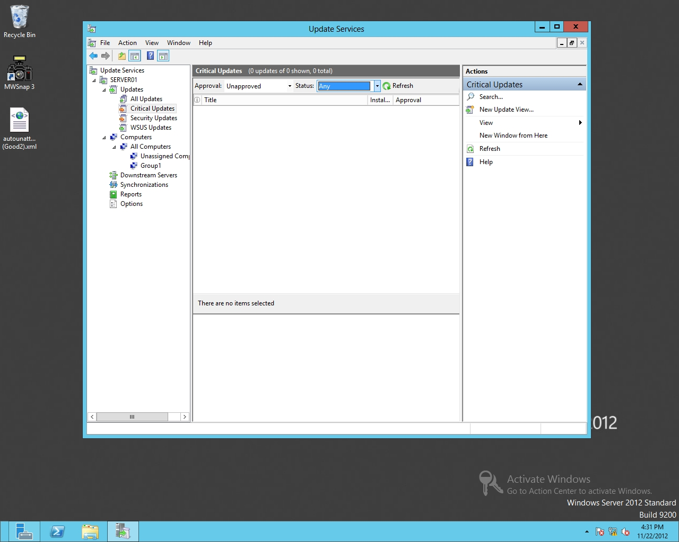

Figure 2-8

Showing unapproved updates

**5.** Click Refresh to display the updates.

**6.** To click several updates, hold the Ctrl key and click several updates. When you're finished selecting your updates, release the Ctrl key.

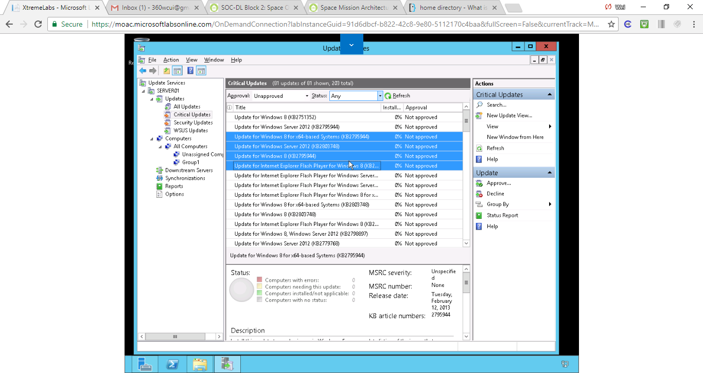

Figure . Step 6. To click several updates, hold the Ctrl key and click several updates. When you're finished selecting your updates, release the Ctrl key

**7.** Right-click the selected update and choose Approve (see Figure 2-9).

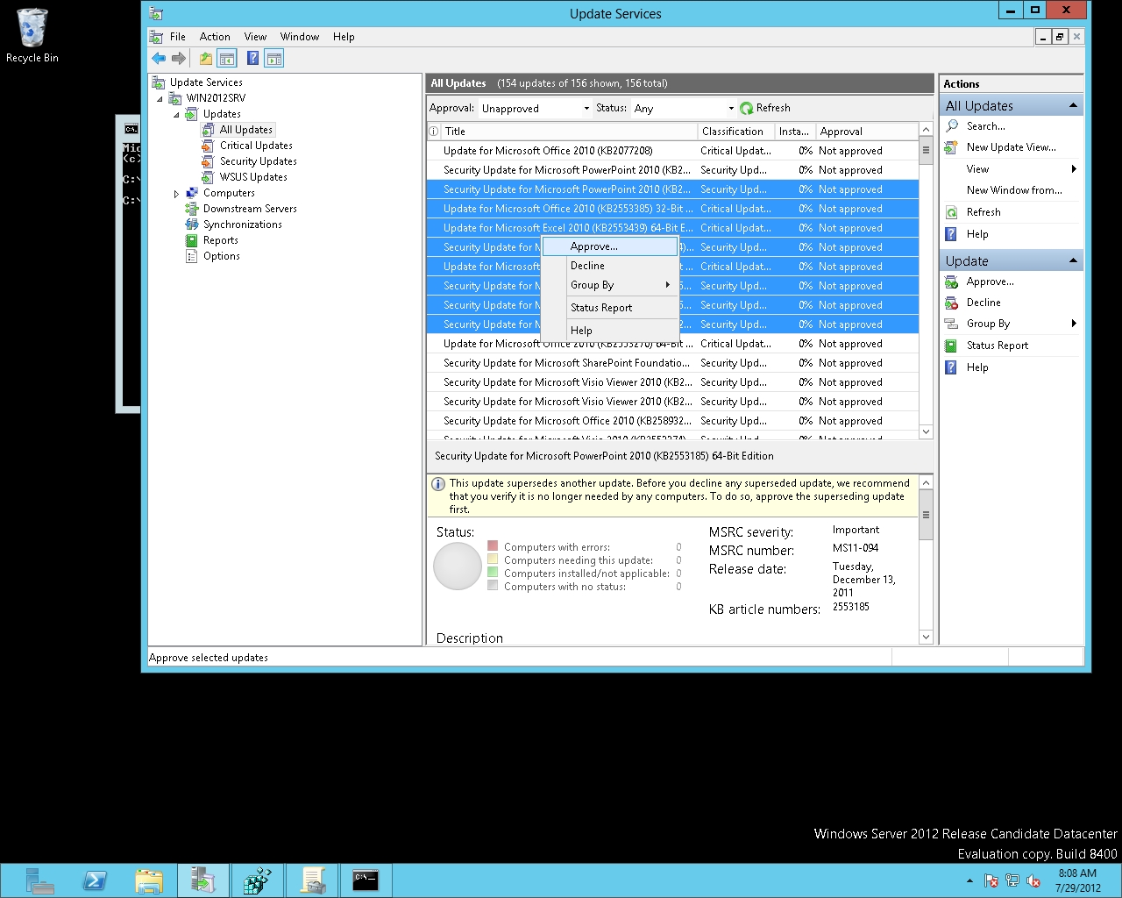

Figure 2-9

Approving updates

**8.** If the Approve Updates dialog box displays, select Group1 and choose Approved For Install. Click OK.

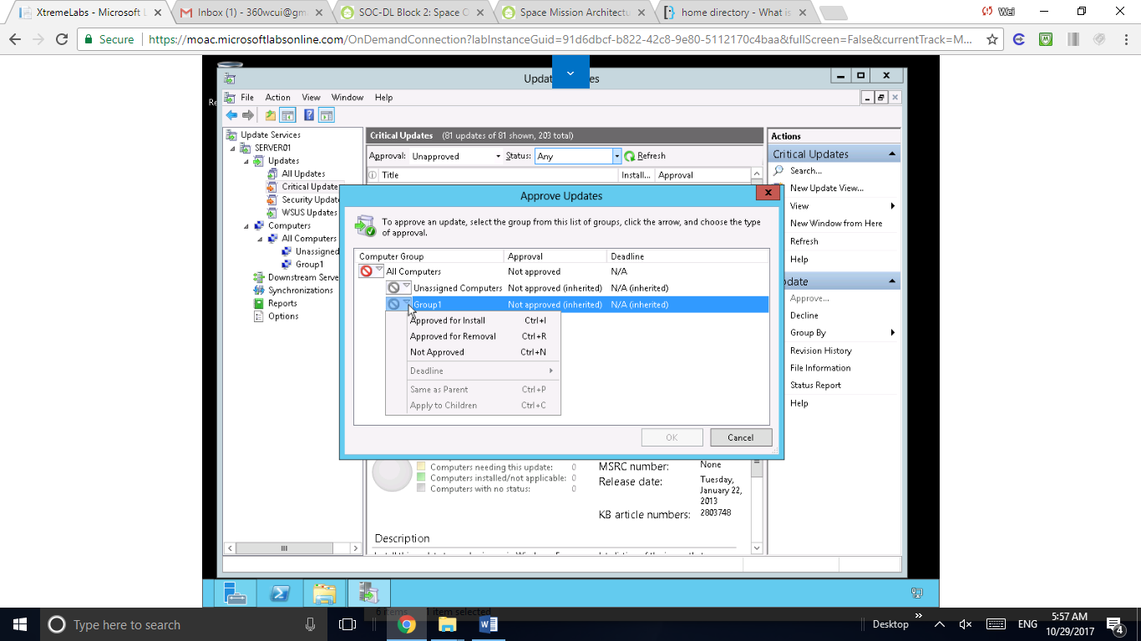

Figure Step 8. If the Approve Updates dialog box displays, select Group1 and choose Approved For Install. Click OK

**9.** If a license agreement displays, prompting you for an update, click I Accept.

**10.** Click Close.

**11.** Close all Windows

**Lab Review Questions**

Mindset Question: The WSUS server has been configured and the clients have been configured to get updates from the WSUS server. Before you approve updates, what should you do first?

I think we should test and verify the updates

**Lab Summary**

The WSUS server was configured and I was ready to get updates from the WSUS server before the execrise. During this exercise, I learned how to approve what updates need to be pushed.